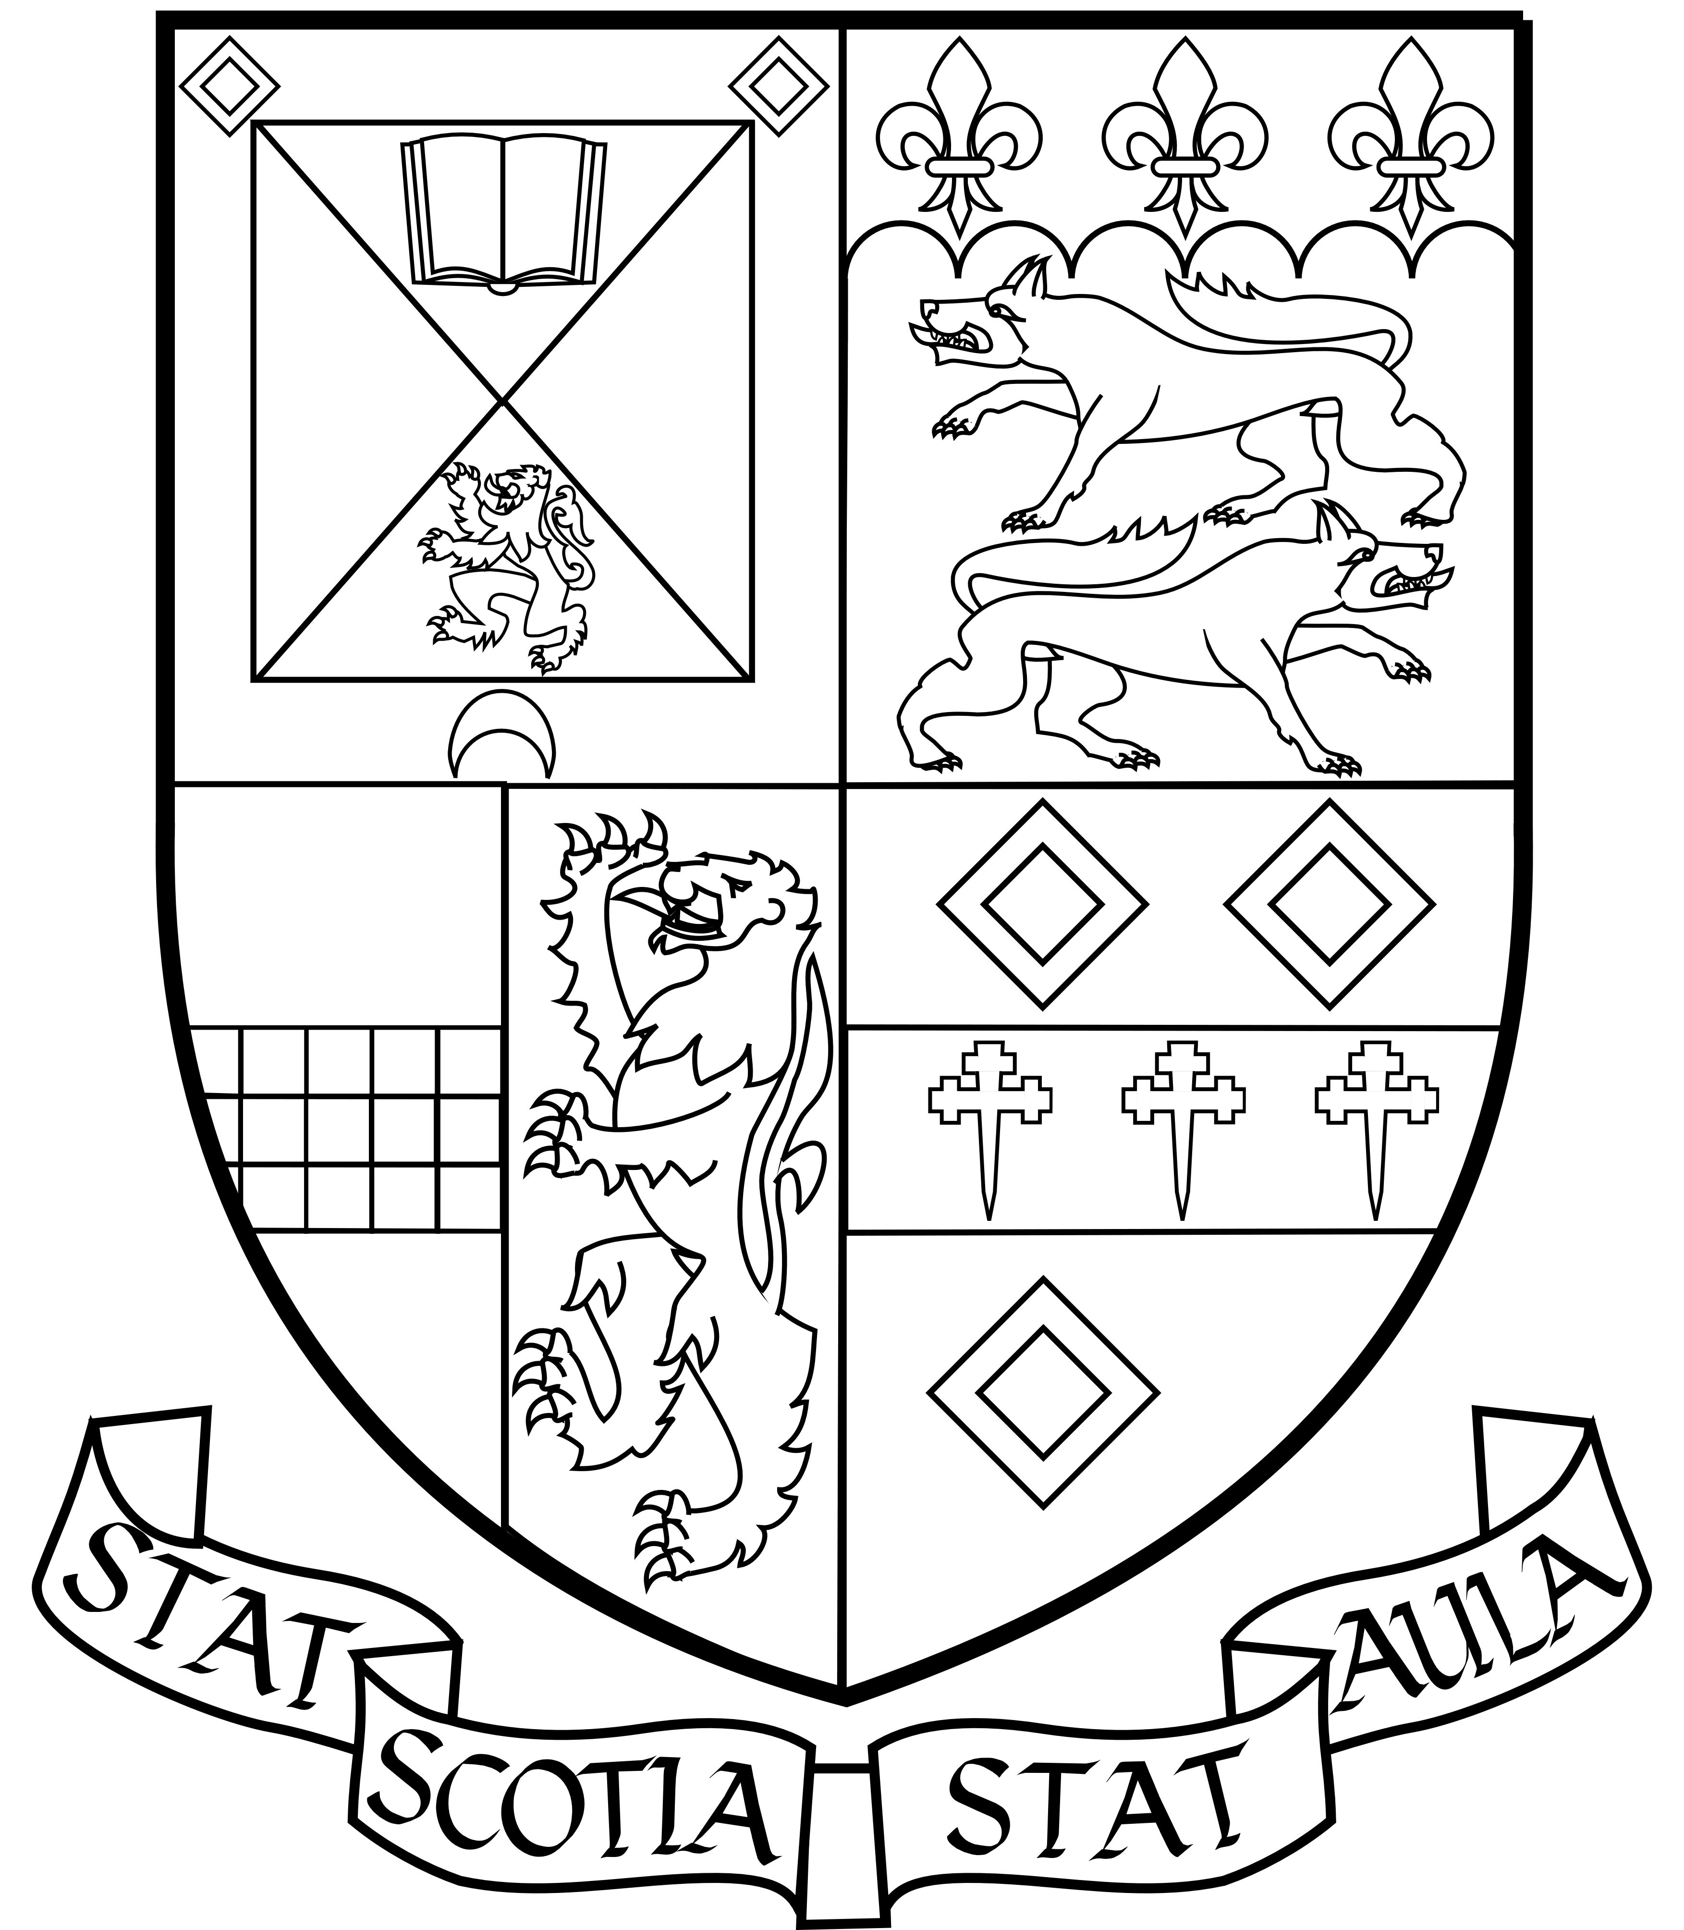
University of St Andrews
Students’ Association
Student Services Council

AGENDA

Tuesday 9th April 2019- Committee Room – 5:30 pm

- Adoption of Agenda
- Apologies for Absence

- Adam Powrie – DoES
- Jamie Minns – DoSDA
- Manaal Mahjoub – SSC Performing Arts
- Cameron Rice – Outgoing Postgraduate Officer
- Chloe – OTR
- Lauren Davis – Environment
- Fiona Murray – AU Pres

- Open Forum

- Reports from the Sabbatical Officers
  - Report of the Athletic Union President –
  - Report of the Association President –
  - Report of the Association Director of Events and Services –
  - Report of the Association Director of Student Development and Activities –
  - Report of the Association Director of Education –
  - Report of the Association Director of Wellbeing –

- Questions for Association Committees
  - Questions for Association Alumni Committee -
  - Questions for Association Community Relations Committee -
  - Questions for Association LGBT+ Committee -
  - Questions for Association Lifelong and Flexible Learners Committee –
  - Questions for Association Environment Committee –
- Questions for SSC Subcommittees
  - Questions for SSC Broadcasting Committee -
  - Questions for SSC Charities Committee -
  - Questions for SSC Debates Committee -
  - Questions for SSC Performing Arts Committee -
  - Questions for SSC Postgraduate Committee –
  - Questions for SSC Societies Committee -
  - Questions for SSC Music Committee -
  - Questions for SSC Volunteering Committee -
  - Questions for SSC Design Committee -
  - Questions for SSC ENTS Committee -
  - Questions for SSC On the Rocks Committee –
  - Questions for SSC Member without Portfolio –

- New General business
  - S. 19-1 Motion to update the students association constitution (See Appendix 1)
  - J. 19-2 Motion to use the correct spelling of ‘Convener’ across all Association (See Appendix 2) Roles and Documentation

- Any other competent business

- Collaborative solutions

Association Officer Reports

Association Alumni Officer – Olivia Wiggins

This weekend is Alumni Festival Weekend! We are expecting plenty of former students to join us for events including the Alumni Dinner, Pub Quiz and a special debate in Lower Parliament Hall. There are also several events hosted by societies and sports clubs that should appeal to current students and Offer Holder Day attendees. The current Alumni sub-committee will be working hard to make sure the festival runs smoothly.

I am planning to contact faculty presidents to discuss setting up subject based careers events over the upcoming academic year. My sub-committee's AGM will be advertised this week.

Association Community Relations Officer – Morgan Morris

Community Relations Applications will close this Sunday and the process of selection will begin next week. We are organizing an Itinerary for representatives from Durham University and Students Association, so watch this space for an event happening on May 1st which you will all be invited to. I am collaborating with Got Consent to run a workshop for my committee and a couple of other groups. The Your St Andrews book will be back for September 2019, so if you would like to contribute something please get in touch with me ASAP. Our May Dip campaign will be coming back with Wellbeing, so again watch this space.

Association Environment Officer – Lauren Davis

I am choosing my committee in the next week. I am so excited to work with a new group of keen beans! Fashion Revolution week is coming up and we have prepared all events running April 22-28th. Additionally, I will be creating a conference with the help of multiple societies next year to discuss Climate Change - if anyone has ideas or would like to get involved, feel free to do so.

Association LGBT+ Officer

Pride is close approaching and glitterball will have happened by this meeting. Also, our AGM is set for the 24th of April. Otherwise, nothing new!

Association Lifelong and Flexible Learners Officer

Nothing to report

SSC Member Reports

SSC Postgraduate Officer – Blake Purchase

Following conclusion of Spring Break, the committee have been particularly focused in preparing for the St Leonard’s College Dinner that takes place on May 2nd. Tickets for this will go on sale on Monday. We are also planning further formal dinners and wine and cheese evenings to take place over at DRA. In terms of other events, we are planning beach bonfires and additional bus trips to locations such as Balmoral. We are also organising the hand-over for the recently co-opted Development Officer role.

SSC Broadcasting Officer – Tom Groves

Since the previous report, submitted 27th March, I have almost finished running the thirty-eight committee interviews, and I’m confident that this year’s team will be able to make a lot of constructive changes to the station. Every position has been filled, pending acceptance from the successful applicants, and emails will be going out by Saturday 6th. Our bonfire event went well, with more than fifty people turning up in total, and the motion to update our constitution was passed.
Currently, I am talking to Broadcast Radio about fixing the faders on the studio mixer, preparing for the handover meeting next week, and finding prizes for the upcoming STAR Awards. We are ready for the Student Experience Showcase on 6th April.
Coming up, the STAR Awards will take place in Sandy’s Bar on Tuesday 30th April, and you should look forward to seeing how the new committee starts to improve the station’s output.

SSC Charities Officer – Frankie Borderie

I am conducting interviews for certain positions on our Executive Committee this week, ahead of our AGM on the 17th. This will allow unsuccessful applicants time to consider running for another position. Student voting for next year's charities will open later this week and we would appreciate if you could all share this as much as possible, it is important to get student engagement with the charities as we raise so much money for them each year (over £100,000!). We are putting together our totals raised this year and hope to have a running figure by our AGM. Our Secret St Andrews event (13th April) is live and boxes have been placed around different university buildings and halls, including the Union, for students to submit secrets to; we have already had a good response with lots of secrets but we always welcome more! There will be an article in The Saint about Race2 and we hope it will be positive. Next week, we will also be collecting Easter eggs for children of domestic abuse victims which we will then give to Fife Women's Aid (local charity) to distribute.

SSC Debates Officer – Toni Valencia

The Union Debating Society had a lot of events throughout this week. On Thursday, we co-hosted alongside the Student Association and Accommodation St Andrews Subcommittee a panel discussion on "Student Housing: Expert Panel Q&A"

Over the weekend, we will be participating in the Offer Holder's Fayre where we will set up a booth for offer holders to find out more about the Union Debating Society and other aspects of why they should attend St. Andrews! We will be also hosting our Alumni Debate for Alumni Weekend. We will have a debate in parliament hall inviting UDS Alumni to go against present UDS members on the motion of “This House Believes That St Andrews Was Better in My Day.” All university students and alumni are more than welcome to attend. It should be a fun event!

Regarding competitive debating, we will send 5 teams and a few judges to Glasgow Ancients. One of our members were also approached to be the Equity Officer for Glasgow Women's.

Our training sessions increased in turnout after our Debate Taste Tester Session on Monday, April 1. After the success of our taste tester, we intend to host more novice debate training throughout the next academic year to encourage more people to join debating anytime of the year.

SSC Design Team Convenor – Mika Schmeling

We’re getting ready for our AGM coming up on the 18th and the end of year student showcase on the 19th. Submissions are accepted for the showcase until the 17th so if anyone has any submissions - feel free to add in! Otherwise getting ready to appoint a new convener. Applications were due in yesterday, and hopefully this week we will have a new DT convener.

SSC ENTS Convenor – Paul Lancaster

Lots of shows, I got re-appointed convener - woo!

SSC Music Officer – Danil Flewelling

This week I have focused on planning logistics for the upcoming (not yet dated) AGM. I have also begun writing questions up for the incoming interviews. Outside of all of that, the a new meeting time has been created (6pm on Fridays), and some of our gear we ordered arrived in the mail.

SSC Performing Arts Officer – Manaal Mahjoub

Our AGM date has been finalised and will be Sunday the 21st of April at 19:00 in Beacon Bar. The Facebook event will be going live soon, and I’d really appreciate it if people could click ‘going’ or ‘interested’ to help publicise it more.

SSC Societies Officer – Markus Lee

Updated Standing Orders for societies with correct information. Some new carve-ups have come to the meeting. We will be going through society award application this coming week.

SSC Volunteering Officer – Lisa Marie Husby

SVS hosted a very successful pub quiz on the 2nd of April. We haven't had many socials the last year but we are planning to have more social activities this coming year. At the moment we are busy planning our AGM and finding new committee members. Applications open this week and our AGM will be on the 22nd of April.

SSC Arts Festival Convener

No Report Submitted

SSC Member without Portfolio – Gavin Sandford

I made graphics that were shared to Facebook letting people know what councils has been up to. So far it has been really successful.

Appendix 1
SSC Motion to update the University of St Andrews Students’ Association Constitution

Owner: Nick Farrer
In effect from: 16th April 2019
Review: 16th April 2019

This SSC Notes:
- That the Constitution of the Students’ Association does not reflect current practice in several areas, to be detailed below.
- That changes to the Constitution must be approved by Councils and the Association Board, approved by the University Court, and notified to the Office of the Scottish Charity Regulator (OSCR).
This SSC Believes:
- That the Constitution is an important document and must be kept up to date.
- That the changes noted below allow the good functioning of the Association.
This SSC Resolves:
- To approve the changes below and keep the Constitution under review and up to date in future.

Proposed: Nick Farrer, Director of Wellbeing
Seconded: Paloma Paige, Association President
Alice Foulis, Director of Education
Parker Hansen, Association LGBT+ Officer
Appendix 1: Changes and rationale

- On page 5, point 1, there is a reference to ‘three elected non-sabbatical Officers of the Association including the Association Chair’ as being members of the Students’ Association Board. The Chair is no longer a member of the Board. As such, the text should be amended to read ‘two elected non-sabbatical Officers of the Association’, and the words ‘including the Association Chair’ should be deleted.
- On page 5, point 5, it is explained that the Chairperson of the SAB ‘shall be elected annually […] from among the non-student members’. It has been custom and practice for many years to restrict this so that the appointees of the University Court are not eligible for this position. The text ‘excluding the appointees of the University Court’ should therefore be added.
- On page 5, point 8, there is a sentence reading ‘he/she will recuse himself/herself’. This text should be amended to read ‘that person will recuse themselves’.
- On page 6, point 9, the text ‘or if unable to do so should recuse themselves’ should be added after ‘act as Trustees of the Association’.
- On page 8, point 5, part ii, there is a reference to ‘the Union Council’. This text should be amended to become plural and a reference to the Executive committee added (‘the Union Councils or Executive committee’).

Appendix 2
(J) Motion to use the correct spelling of ‘convener’ across all Association roles & documentation
Owner: William Thompson
Responsibility of: Gavin Sandford (SSC Member without Portfolio) In effect from: Immediately
Review date: 1st September 2019
This petition notes:
- The correct spelling of the word meaning to convene a group of people is ‘convener’.
(Appendix A)
- Across the association roles and documentation the word ‘convenor’ frequently appears.
(Appendix B)
This petition believes:
1. For clarity the association should use the correct spelling everywhere.
This petition resolves:
1. Change all occurrences of the word ‘convenor’ to ‘convener’ across all association
documentation.
Proposer:
William Thompson, Gavin Sandford & petition members
