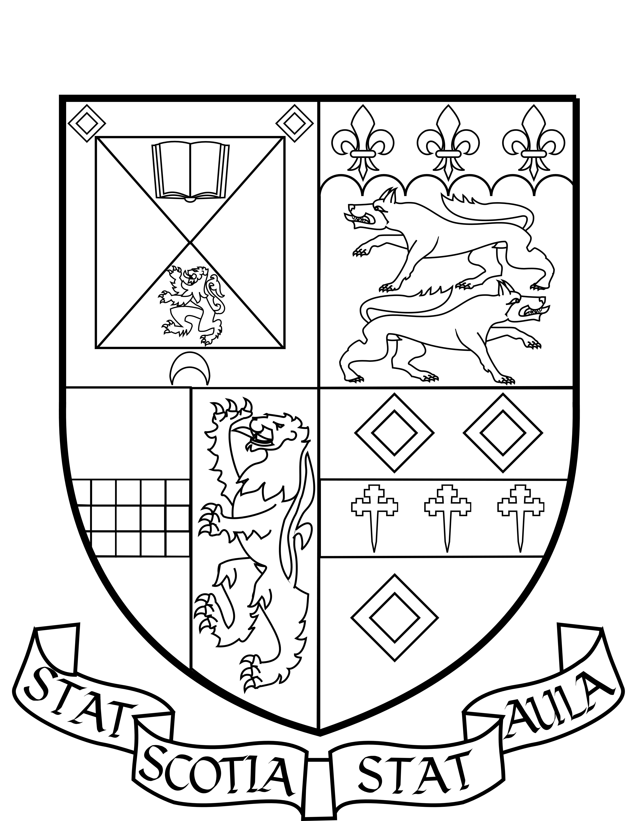

EQUAL OPPORTUNITIES
What is your nationality?

What is your ethnicity?

How would you describe your gender identity?

What are your religious beliefs, if any? (Including lack of religious belief)

How do you identify in terms of sexual orientation?

The Equality Act 2010 defines a disability as a ‘physical or mental impairment which has a substantial and long-term adverse effect on a person’s ability to carry out normal day-to-day activities’. An effect is long-term if it has lasted, or is likely to last, over 12 months.
Do you consider yourself to have a disability or disabilities (circle whichever applies)? Yes No
If you do consider that you have a disability or disabilities, please provide details here:

MONITORING FORM

The Association is committed to equality of opportunity and diversity in all activities including recruitment and selection. For this reason, we collect information relating to protected characteristics on an anonymous basis.
This information will be used solely to monitor equal opportunities in employment. All data will be stored confidentially and cannot be linked back to you: forms will be separated from other paperwork after completion and processed separately. If you agree to provide this information, please complete the following fields. If you prefer not to answer one or more of these questions, please leave that field blank and complete only those you wish to.
Please note that we do not provide a checklist of options – instead, we encourage respondents to self-identify and respond with whatever terms they prefer.

