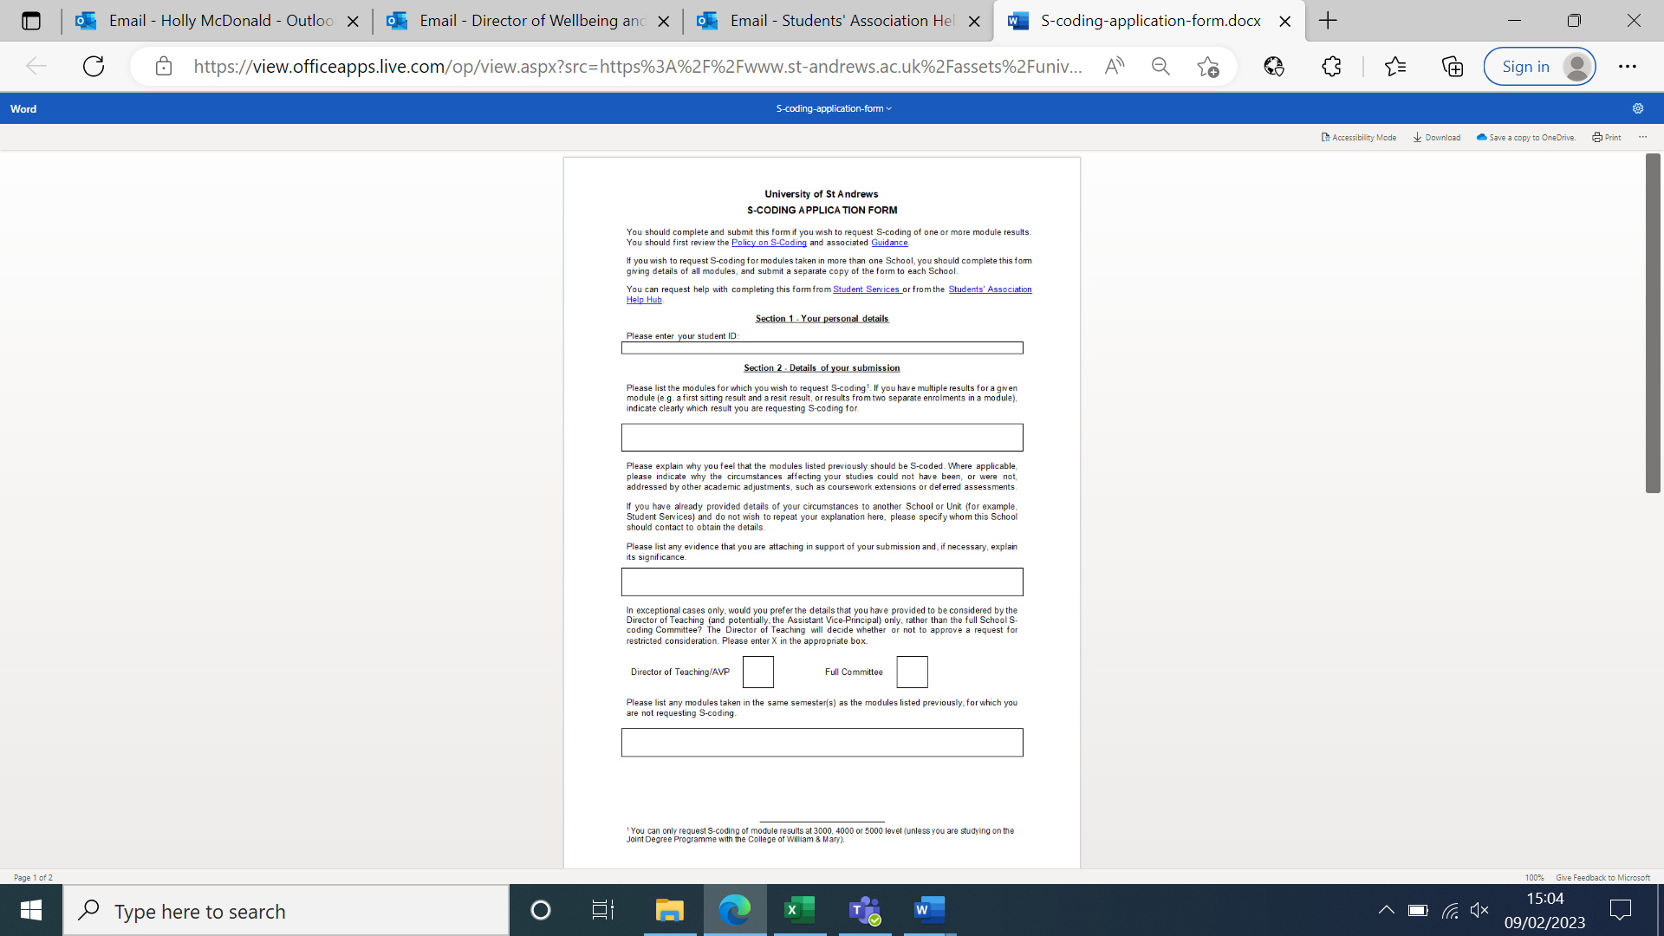

Explain why the modules you listed above should be S-coded. Explain your circumstances (if you feel able to), including who you told, any adjustments you were given, and why these did or did not help. If you do not feel able to re-explain your circumstances in depth, state here who they should contact from the University to find out about what happened (e.g. Disability Team, Student Services)

Type in a list of the evidence you have, i.e.

[1] Doctors’ note

[2] Letter from family/friend/partner

If your evidence is particularly sensitive, you can ask that it is only seen by the DoT or AVP Dean/Provost. There is no guarantee that they will allow this, but you can make the request.

Type in your matriculation number.

Type in the modules you would like to S-code for (module code and title).

Type in a list of the other modules you’re doing that you are NOT requesting to S-code for.

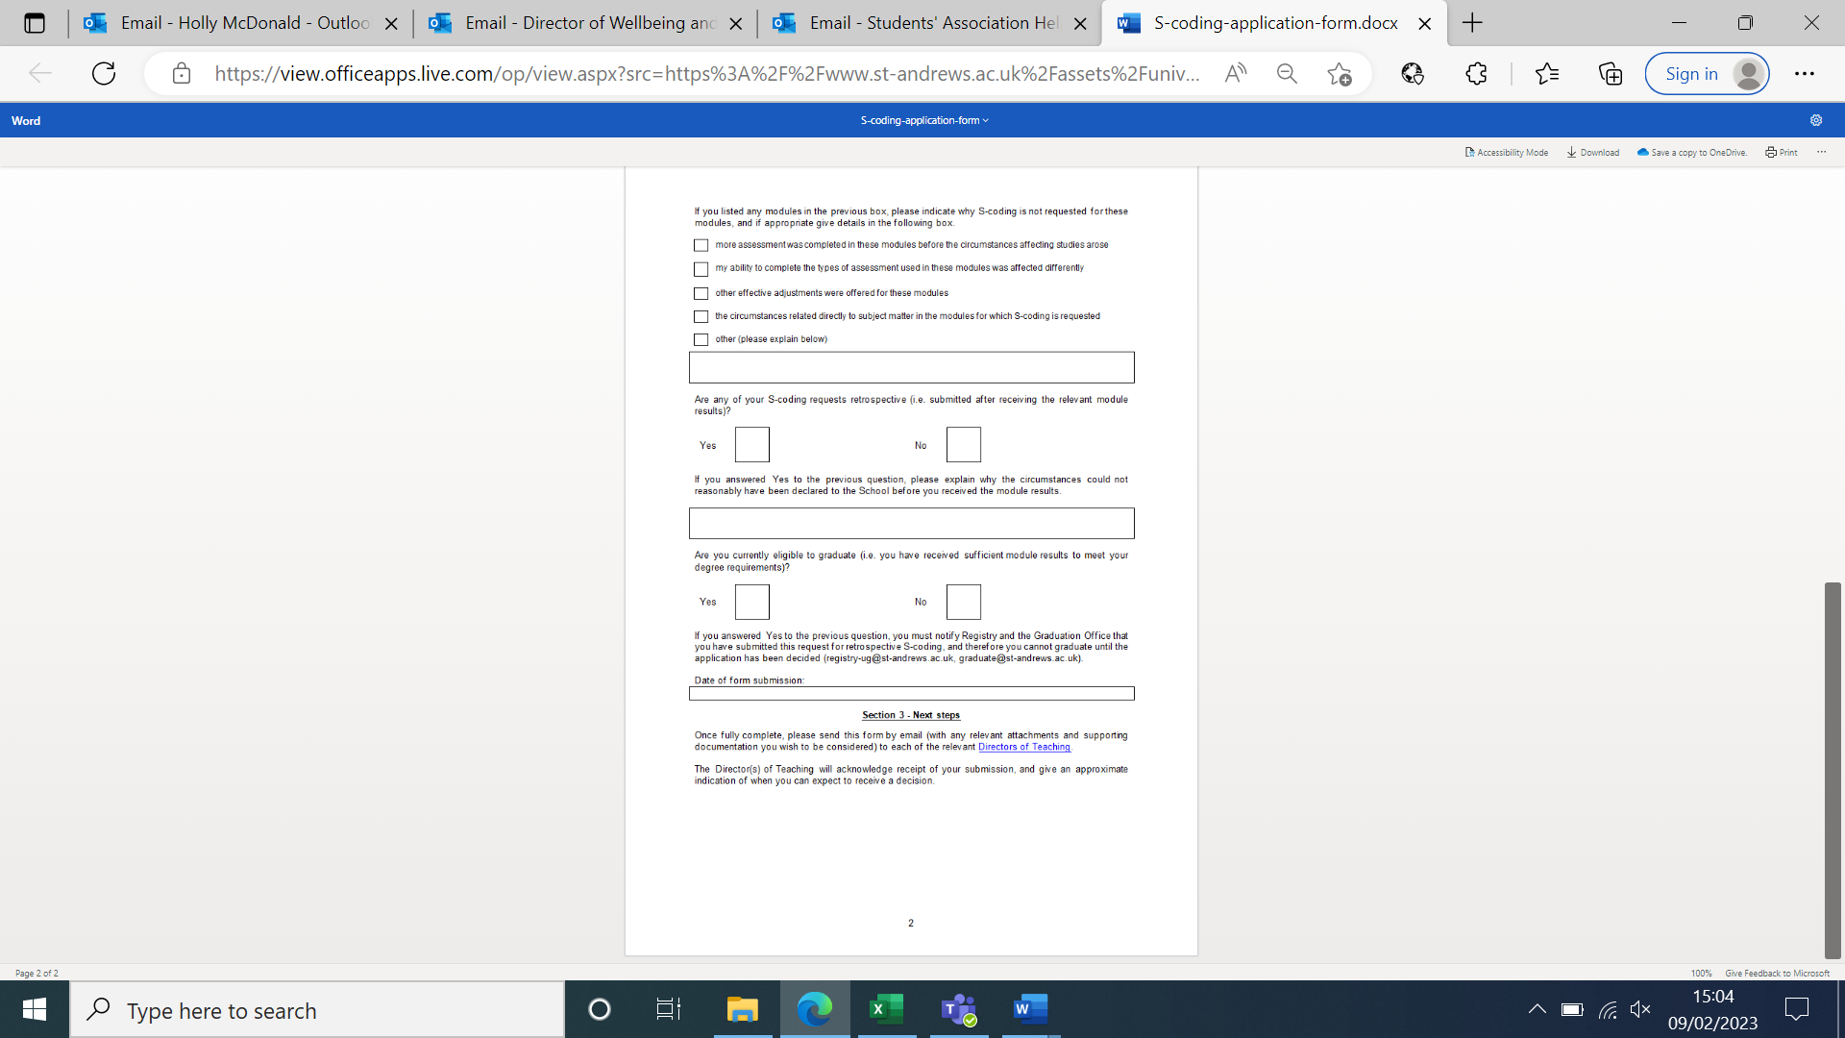

If you are S-coding for modules after you’ve already received grades, explain here why you did not S-code or seek adjustments before.

Type a ‘X’ in the box to say if you are S-coding after or before you have received module or assessment grades/marks.

Type in the date of when you are sending off the form.

Put an ‘X’ in the box to say why you are not S-coding for other modules.

If none of these reasons apply, type your reason into the ‘Other’ box.

Put an ‘X’ in the box to show if you are currently on track to graduate (i.e. you have enough credits to already without S-coding).

If you are on track to graduate, you need to email registry@ and graduation@ to explain your situation, and that you cannot graduate until the S-coding decision has been made.

Send your form and evidence to the Director of Teaching for the School(s) your modules come from.