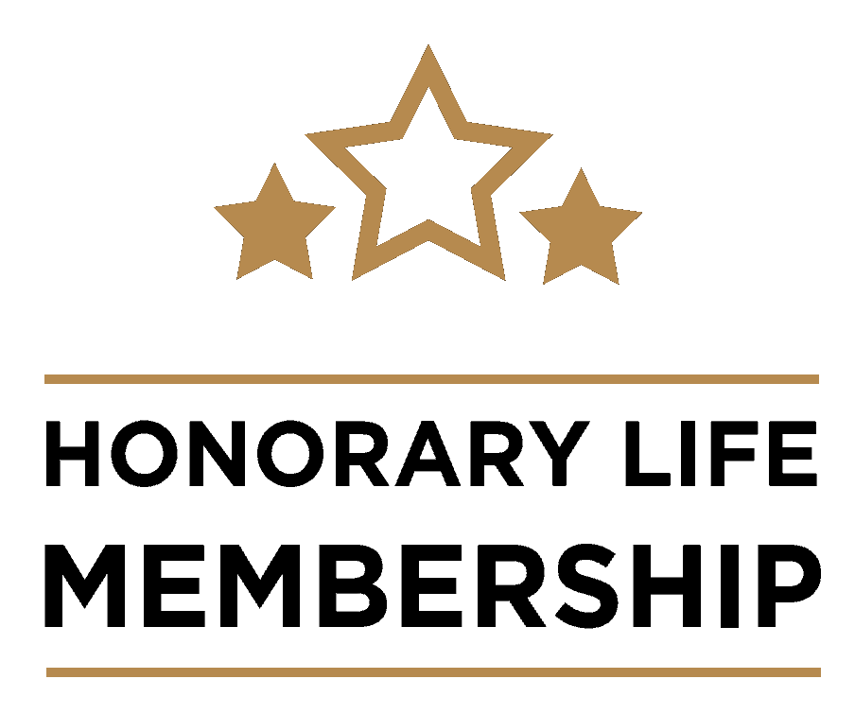
St Andrews Students’ Association HLM Nomination Form 2021
Nominee name |  | Email
Describe this person and their achievements in one sentence.
Or just say something nice about them (max. 1 sentence)!
Key groups / areas of involvement.
Please list the groups and responsibilities this person has held or been involved in (short list).
Why does this student deserve a HLM nomination?
Please use specific examples detailing how this student has gone above and beyond with their volunteering and work to aid the St Andrews student experience (max. 400 words).

Proposer name |  | Email
Successful candidates will be given a copy of their nominations. Please mark in the box to the right if you wish for your nomination to remain anonymous.

