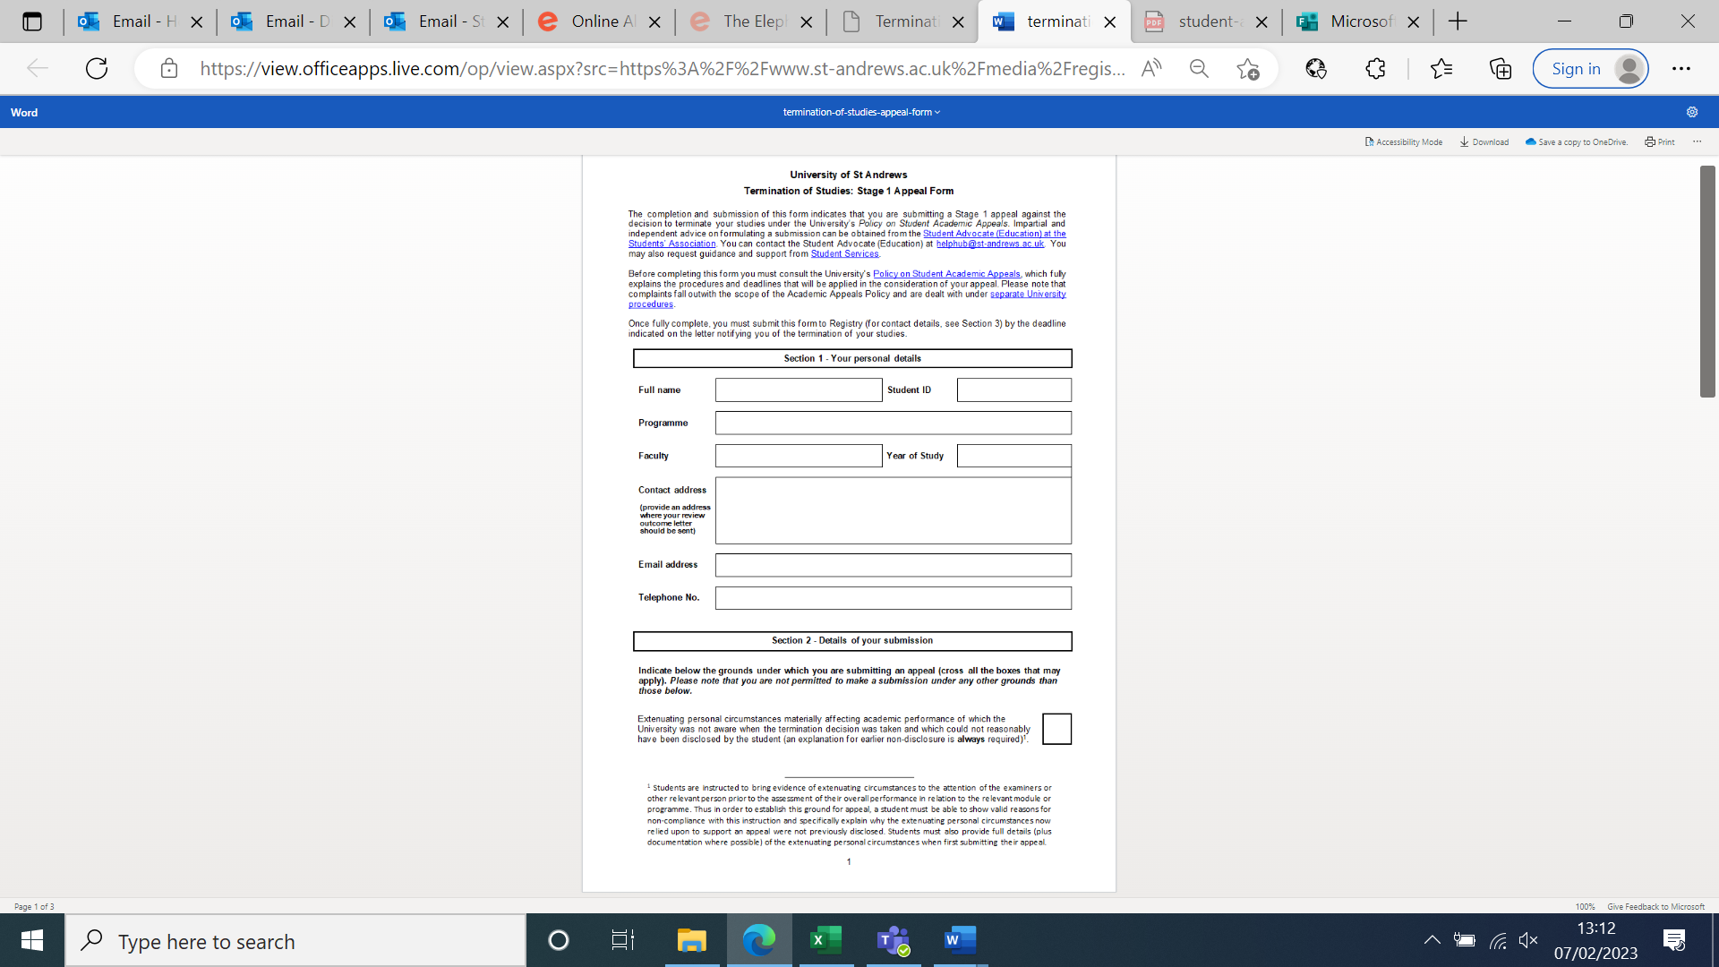

Include your contact address, preferably where you live during term time if appealing during term time.

Or type in the safest address that you would like to be used.

Type in your programme (e.g. BSc (Hons) Psychology)

Type in your phone number

Type in your St Andrews email address

Type in your Faculty (Arts + Divinity, Science + Medicine)

Type in your year of study (e.g. 1st Year)

Type in your student ID/matriculation number

Type in your name

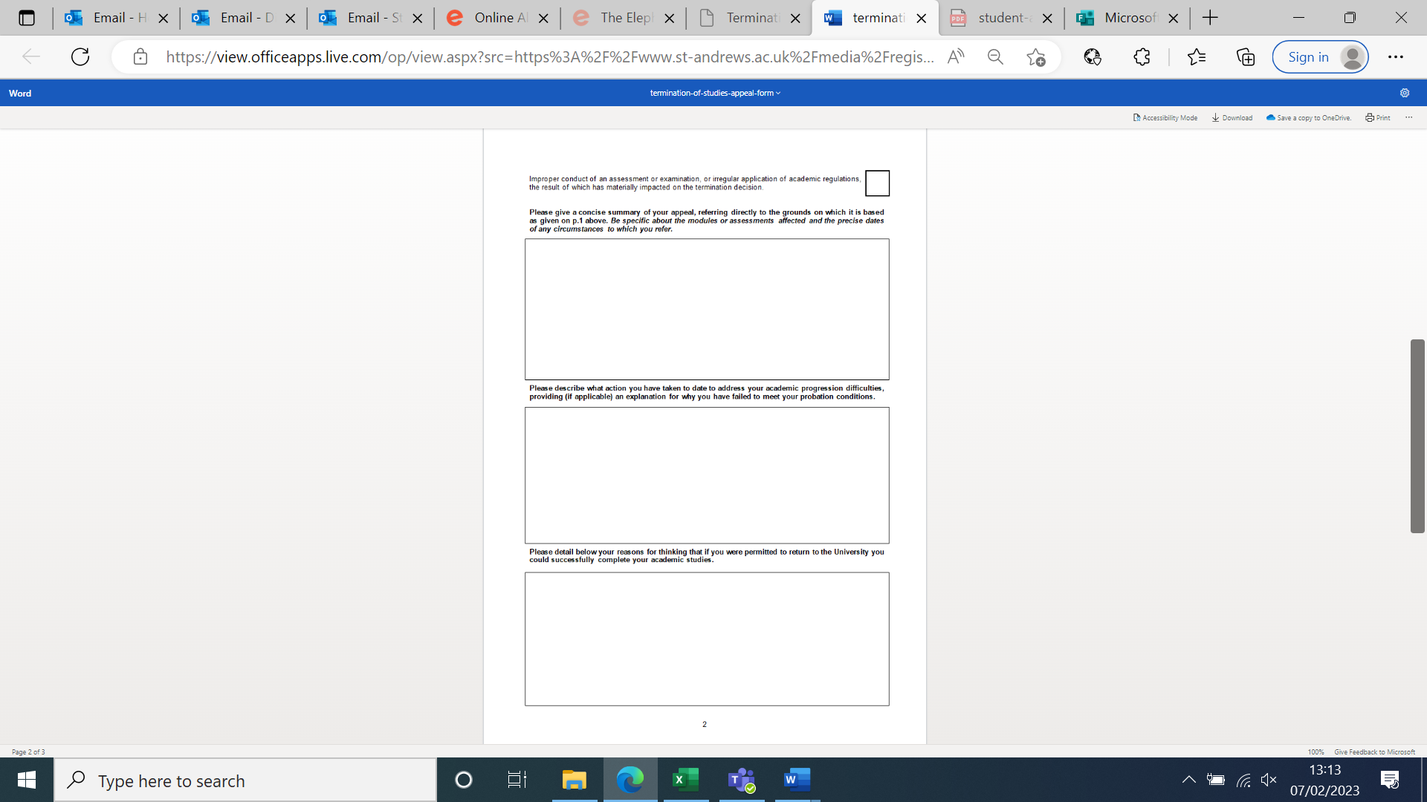

Explain as clearly as you can why you are appealing, referring directly to the grounds you selected in the tick box above.

Mention specific modules and assessments that were affected by these circumstances, with dates if you can.

It may be useful to write this with a clear timeline from when you first had difficulties to now.

Explain how you would make sure you don’t have your studies terminated again.

It's best to look at how many credits you’d need to take to make up those lost, so you can make a more convincing plan. You can speak to the HelpHub about this, as well as your Adviser of Studies, and look at the Senate Regulations.

Also mention any additional supports you will pursue to help you, such as study skills with CEED, accessing specific help from Student Services, and any external supports you will use to help, such as medical help or private therapy as relevant.

Here you need to mention anyone you’ve spoken to about your academic difficulties. This may include your Adviser of Studies, specific academic staff on your course, Student Services, etc.

If you’ve taken any CEED courses to help, include them here too, with dates of when you took these sessions.

Type an ‘X’ in the box best applies to your case – you can tick both if both apply.

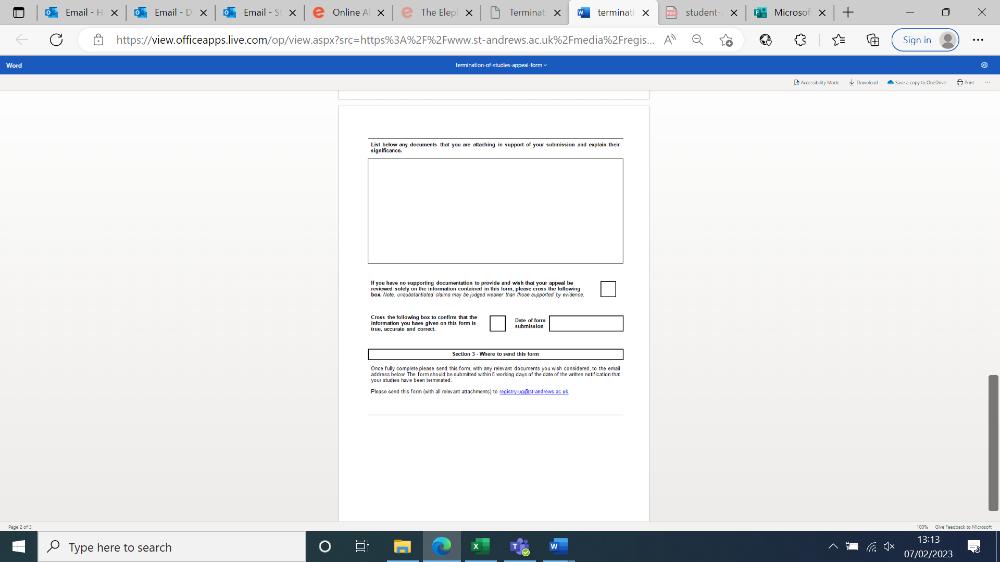

We always recommend that you give evidence to support your appeal form. This could be doctors’ notes, proof of prescriptions, evidence of meetings with Student Services, a letter from a family member, partner, or friend who knows about your circumstances, etc. List everything in the order you present them i.e.

[1] Doctor’s note [date]

[2] Email chain demonstrating appointments with Disability Adviser [dates].

Type an ‘X’ in the box to say that everything in this form is true.

Type in the date of when you email the form.