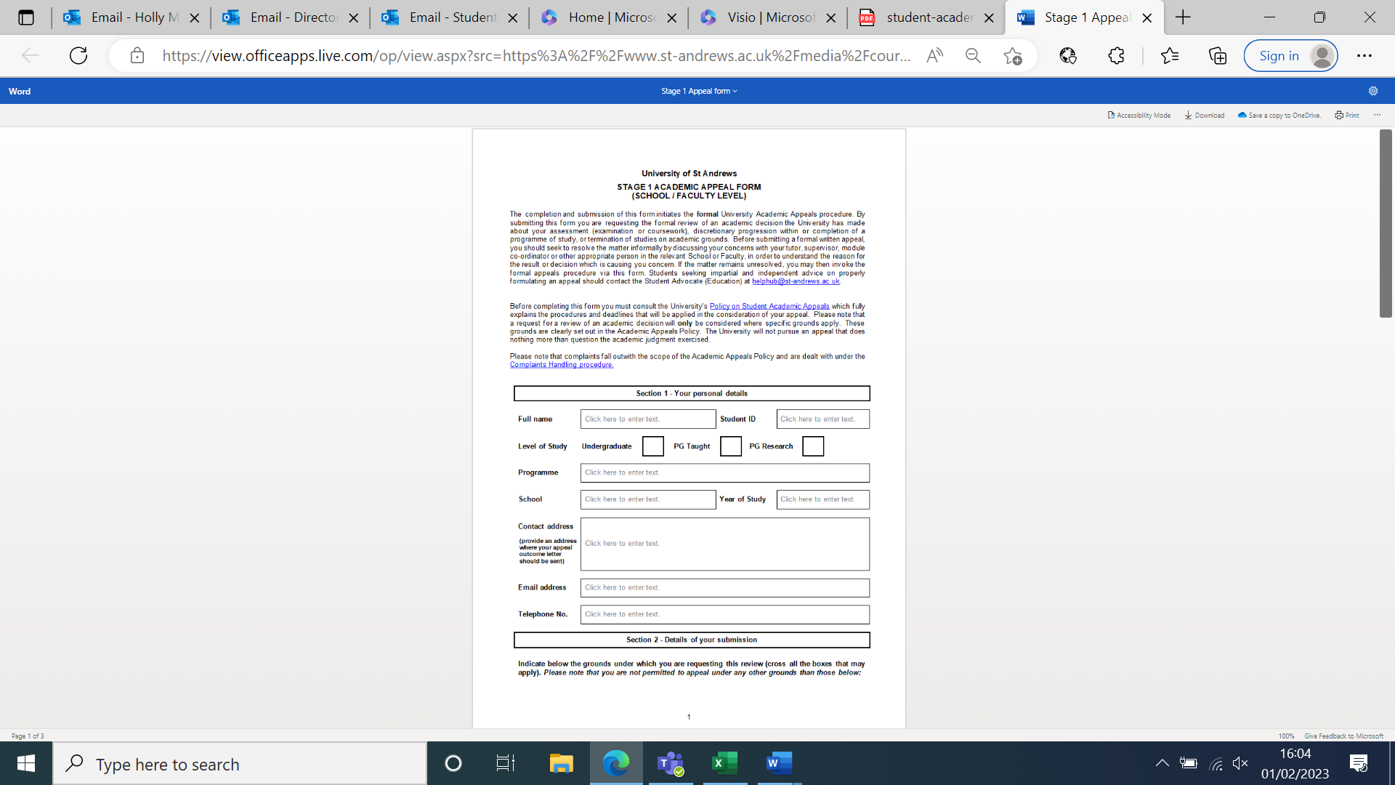

Type in your year of study (e.g. 1st Year).

Include your contact address, preferably where you live during term time if appealing during term time.

Or type in the safest address that you would like to be used.

Type in your St Andrews email address.

Type in your programme (e.g. BSc (Hons) Psychology).

Type an ‘X’ in your level of study.

Type in your School Name (e.g. School of Psychology and Neuroscience).

Type in your student ID/matriculation number.

Type in your name.

Type in your phone number.

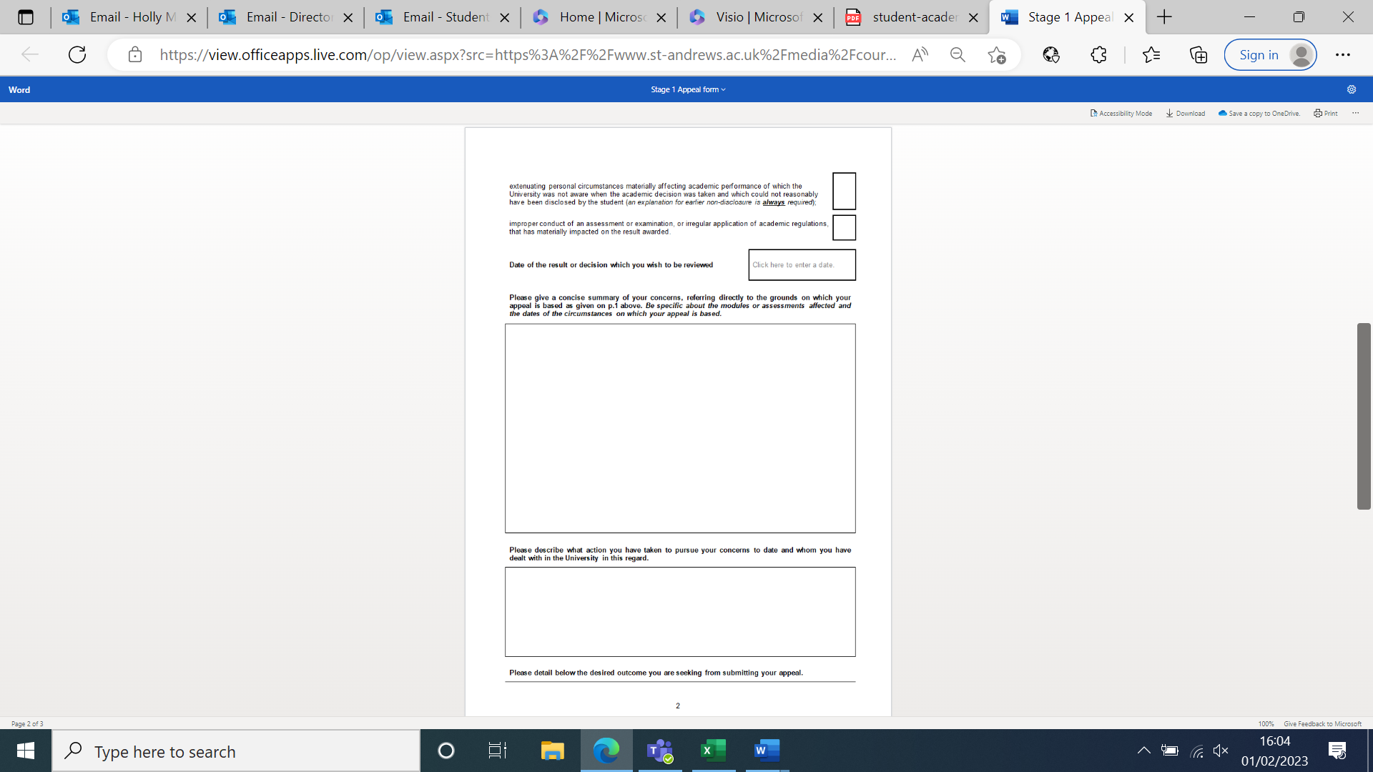

Explain what happened, why you are appealing, and explain in as much detail as can about extenuating circumstances and/or the improper conduct of assessment or academic rules.

Outline what steps you’ve taken so far, and explain who you have spoken to about this, what you spoke about, and when.

For example, if you spoke to academic staff about your issues, or to Student Services about your circumstances, or CEED for help with academic skills.

Type in the date from your outcome letter.

Tick which box best applies to your case – you can tick both if both apply.

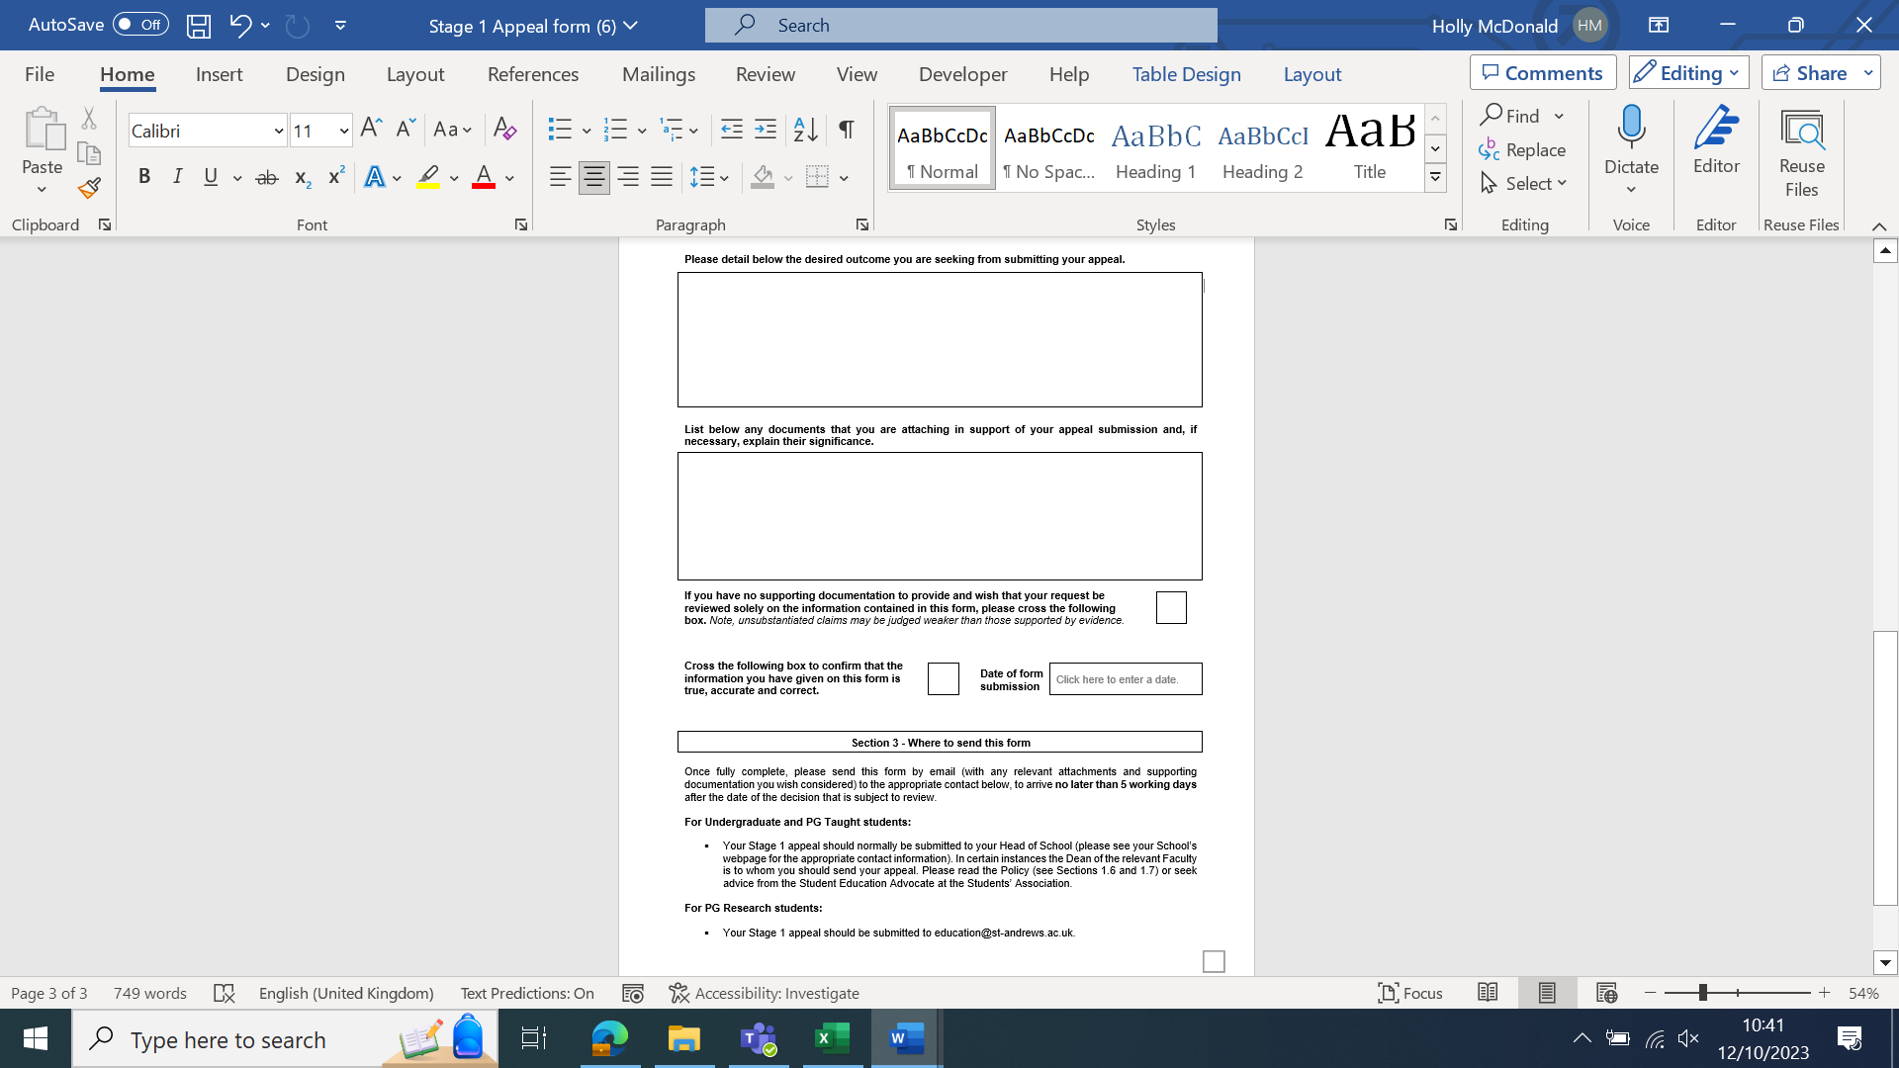

Type an ‘X’ in the box to say that everything in this form is true.

Explain what you would like to happen as a result of submitting your appeal e.g. your grade to be re-evaluated in light of your circumstances.

Type in the date of when you email the form.

We always recommend that you give evidence to support your appeal form. This could be doctors’ notes, proof of prescriptions, evidence of meetings with Student Services, a letter from a family member, partner, or friend who knows about your circumstances, etc. List everything in the order you present them i.e.

1. Doctor’s note [date]
2. Email chain demonstrating appointments with Disability Adviser [dates]

**Undergraduate and Taught Postgraduates**

* Normally, you email your form to **your** **Head of School**
* If you are a final year UG or a PGT student who is appealing your module grade after you’ve received your degree classification, email your form to **academicappeals@**

**General Degree students**

* When appealing final module grades, email your form to **academicappeals@**

**Research Postgraduates**

* Email your form to **academicappeals@**